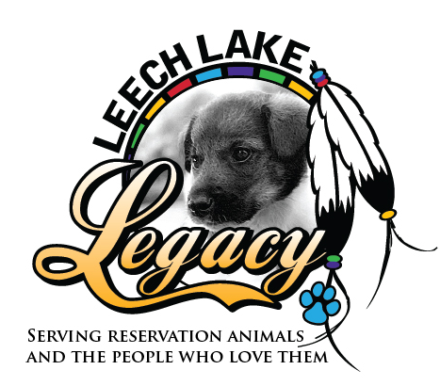

Leech Lake Legacy is hosting a
Nail Trim Event*
(*Suggested donation of $10 per animal)

Date:
Saturday, October 13, 2018

Time:
10:00 a.m. - 12:30 p.m.

Location:
Chuck & Don’s
Calhoun Village Shopping Center
3246 West Lake Street, Minneapolis

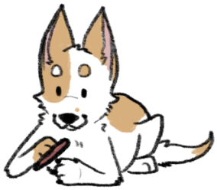

Leech Lake Legacy is a charitable organization helping dogs and cats on the Leech Lake Reservation with spay/neuter, wellness, food and emergency medical care. We also do weekly transports to rescues of stray and surrendered animals from the Reservation.

Please visit our website and Facebook page to read more about the great work we do helping dogs and cats on Leech Lake Reservation!
http://leechlakelegacy.org/
https://www.facebook.com/LeechLakeLegacy
1-866-LEGACY3 (1-866-534-2293)

